**OSINT exercise #005 (Gralhix)**

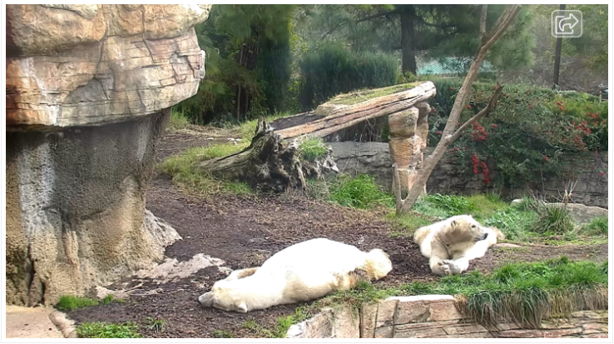

To identify the zoo in which these polar bears are located, I start with a Google reverse image search. I don’t find any pictures that match this scene, but I do find some results that resembles some of the rock structures. All these results seem to point to the San Diego Zoo. When I go to the website of the San Diego Zoo, I indeed see they have live cam footage of polar bears, although the scene I am seeing now does not match up with the scene from the photo. But maybe there are multiple webcams set up in their enclosure, so I look deeper into the website. I see the enclosure referenced as the Conrad Prebys Polar Bear Plunge. First, I open this location in Google maps, to see if I can match the location using Google street view. Indeed, I am able to find images from street view in which I recognize the big rock structure on the left of this photo. I however don’t see the other rock structure, but then again, the street view photo is from 2009. In Google Earth Pro I can see the same rock structure and I can also see the outlines of what I believe to be the other rock structure. So this confirms for me that the photo is from San Diego Zoo, and the polar bears were located at coordinates: 32.73445610546583, -117.15457013121585. Now to find the temperature of when this picture was taken, I Google ‘temperature San Diego January 15 2023 2PM’. On the wunderground.com website I find a nice graph of the temperatures throughout that day in San Diego, and at 2PM it was 63 degrees Fahrenheit.